Batch: B2 Roll No.: 16010121200

Experiment / assignment / tutorial No. 5

Title: To develop UML diagrams for selected project
______________________________________________________________________
Aim: To learn and understand the way of creating various UML diagrams for requirement analysis
______________________________________________________________________
CO:
______________________________________________________________________

Books/ Journals/ Websites referred:
- Roger Pressman, “Software Engineering”, sixth edition, Tata McGraw Hill.
- System Analysis & Design by Satzinger, Jackson and Burd, Cengage Learning, 2007
- System Analysis and Design Methods by Jeffery l. Whitten, Lonnie D Bentley,McGraw Hill, 7th edition.
- System Analysis and Design by Alan Dennis, Barbara H. Wixom, Roberta M. Roth,Wiley India 4th edition
- http://en.wikipedia.org/wiki/Software_requirements_specification
- http://en.wikipedia.org/wiki/Use_case

__________________________________________________________________
Pre Lab/ Prior Concepts:
In software and systems engineering, a use case is a list of steps, typically defining interactions between a role (known in Unified Modeling Language (UML) as an "actor") and a system, to achieve a goal. The actor can be a human or an external system.
In systems engineering, use cases are used at a higher level than within software engineering, often representing missions or stakeholder goals. The detailed requirements may then be captured in Systems Modeling Language (SysML) or as contractual statements.
As an important requirement technique, use cases have been widely used in modern software engineering over the last two decades. Use case driven development is a key characteristic of process models and frameworks like Unified Process (UP), Rational Unified Process (RUP), Oracle Unified Method (OUM), etc. With its iterative and evolutionary nature, use case is also a good fit for agile development.
A sequence diagram is a graphical view of a scenario that shows object interaction in a time-based sequence of what happens first, what happens next.
Sequence diagrams establish the roles of objects and help provide essential information to determine class responsibilities and interfaces.

In UML, class diagrams are one of six types of structural diagram. Class diagrams are fundamental to the object modelling process and model the static structure of a system. Depending on the complexity of a system, you can use a single class diagram to model an entire system, or you can use several class diagrams to model the components of a system.

Class diagrams are the blueprints of your system or subsystem. You can use class diagrams to model the objects that make up the system, to display the relationships between the objects, and to describe what those objects do and the services that they provide.

In its basic form, an activity diagram is a simple and intuitive illustration of what happens in a workflow, what activities can be done in parallel, and whether there are alternative paths through the workflow. Activity diagrams as defined in the Unified Modeling Language are derived from various techniques to visually illustrate workflows. Activity diagrams are used to visualize the workflow of a business use case. A complete workflow description will have a basic flow, and one or several alternative flows. This workflow has a structure that we can define textually, using informal if, if-then-else, or does-until statements of various kinds. For a simple workflow with a simple structure such textual definitions may be quite sufficient, but in the case of more complex structures, activity diagrams help to clarify and make more apparent what the workflow is. Historically, activity diagramming techniques have mostly been used in the business process modeling domain, but this article will also briefly discuss how you can use it in the system modeling domain.

Requirement Modeling:
Significance of every diagram is to be written
- Use Case Diagram
Use-case diagrams model the behaviour of a system and help to capture the requirements of the system. They describe the high-level functions and scope of a system. These diagrams also identify the interactions between the system and its actors. The use cases and actors in use-case diagrams describe what the system does and how the actors use it, but not how the system operates internally.
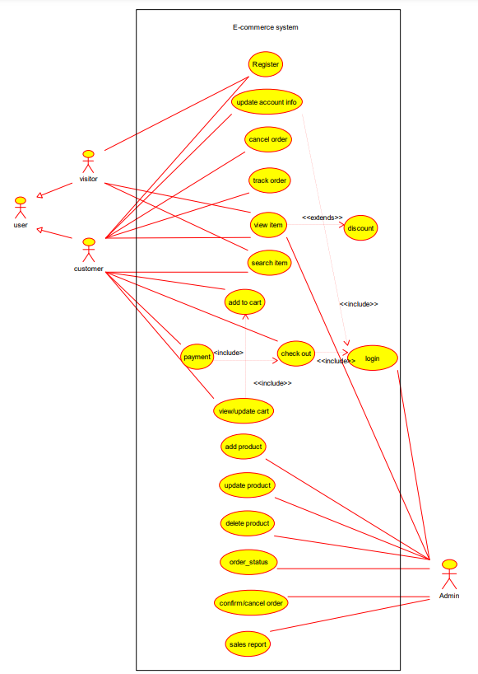

- Activity Diagram
Activity diagrams provide a view of the behavior of a system by describing the sequence of actions in a process. Activity diagrams can also show parallel or concurrent flows and alternate flows.
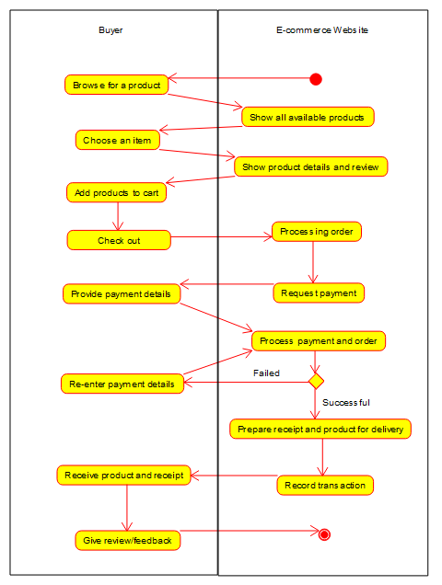

- Class Diagram
Class diagrams are fundamental to the object modeling process and model the static structure of a system. Class diagrams are the blueprints of a system or subsystem. They can be used to model the objects that make up the system, to display the relationships between the objects, and to describe what those objects do and the services that they provide.
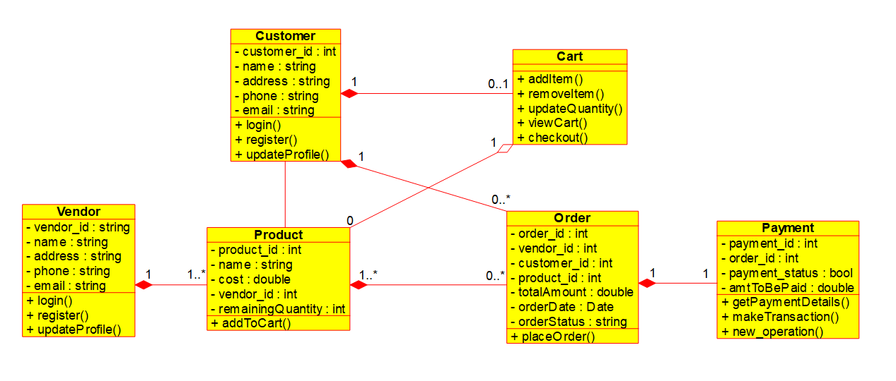
- Sequence Diagram
A sequence diagram illustrates the sequence of messages between objects in an interaction. It consists of a group of objects that are represented by lifelines, and the messages that they exchange over time during the interaction. A sequence diagram shows the sequence of messages passed between objects and the control structures between objects.
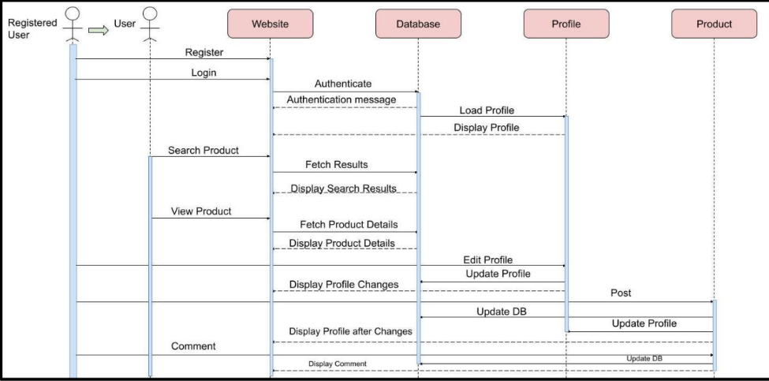

Virtual Lab Link: http://vlabs.iitkgp.ernet.in/se/3/exercise/
Virtual Lab Link: http://vlabs.iitkgp.ernet.in/se/5/exercise/
Virtual Lab Link: http://vlabs.iitkgp.ernet.in/se/6/
Virtual Lab Link: http://vlabs.iitkgp.ernet.in/se/7/

Conclusion:
Advantages of UML diagrams such as Use Case, Activity, Class, and Sequence.
Use case:
- Use cases help to capture the functional requirements of a system.
- Use cases are traceable.
- Use cases can serve as the basis for the estimating, scheduling, and validating effort.
- Use-case can evolve at each iteration from a method of capturing requirements, to development guidelines to programmers, to a test case and finally into user documentation.

Activity:
- Demonstrate the logic of an algorithm.
- Describe the steps performed in a UML use case.
- Illustrate a business process or workflow between users and the system.
- Simplify and improve any process by clarifying complicated use cases.
- Model software architecture elements, such as method, function, and operation.

Class:
- Class diagrams give you a sense of orientation.
- They provide detailed insight into the structure of your systems. At the same time, they offer a quick overview of the synergy happening among the different system elements as well as their properties and relationships.
- Class diagrams are simple and fast to read. With the right software they are also easy to create.
- They are the foundation for creating systems.

Sequence:
- Represent the details of a UML use case.
- Model the logic of a sophisticated procedure, function, or operation.
- See how objects and components interact with each other to complete a process.
- Plan and understand the detailed functionality of an existing or future scenario.

Post Lab Descriptive Questions:
- Where do use cases fit in the software development life cycle?
A use case is a written description of how users will perform tasks on your website. It outlines, from a user’s point of view, a system’s behavior as it responds to a request. Each use-case is represented as a sequence of simple steps, beginning with a user’s goal and ending when that goal is reached.
- Compare sequence diagram with collaboration diagram. Explain pros and cons of each.
Sequence Diagram | Collaboration Diagram
Used to visualize the sequence of calls in a system. | Used to visualize the organization of objects.
Time sequence is the main focus. | Object organization is the main focus.
Better suited for ananysis of activities. | Better suited for depicting simpler interaction of objects.
Shows the sequence of messages that flow from one object to another. | Shows the structured organization of the system and the messages sent.

- List different notations used in Class diagram with example.
Different Notations used in class diagram are:
      - Class:
Classes represent the central objects in a system. It is represented by a rectangle with up to 3 compartments.
The first one shows the class’s name, while the middle one shows the class’s attributes which are the characteristics of the objects. The bottom one lists the class’s operations, which represents the behaviour of the class.
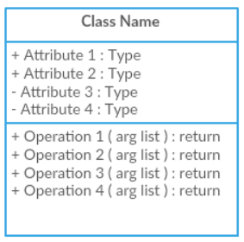
      - Interface:
The interface symbol in class diagrams indicates a set of operations that would detail the responsibility of a class.
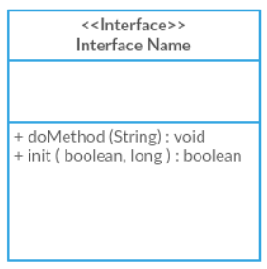

      - Package:
The package symbol is used to group classes or interfaces that are either similar in nature or related. Grouping these design elements using the package symbols improves the readability of the diagram.
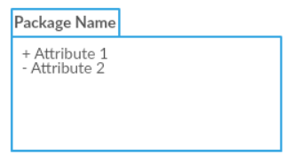

      - Relationships:
